**GTRideShare - FG1**

1. Do you commute or have you commuted in the past?

Yes No

1. Would you consider the app to be convenient?
2. Strongly Disagree
3. Disagree
4. Neutral
5. Agree
6. Strongly Agree

1. Would you use this app if it was available for you?  
     
    Yes No
2. What do you not like about this app (choose all that apply)
   1. Not satisfied with how Trust and Safety is handled
   2. I would like more control when using the app
   3. Too complicated to use
   4. Nothing

5. If you chose anything other than “Nothing” for Number 4, please briefly elaborate as to why.

6. Which do you prefer: Screen 1 or Screen 2?

1. 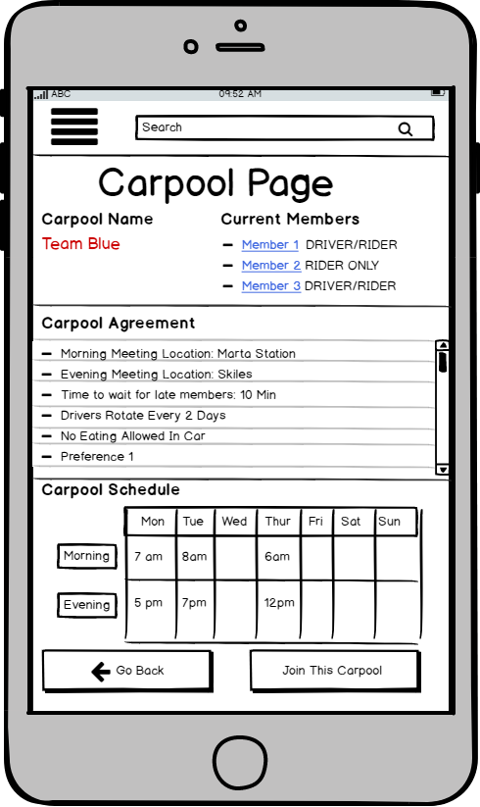 B)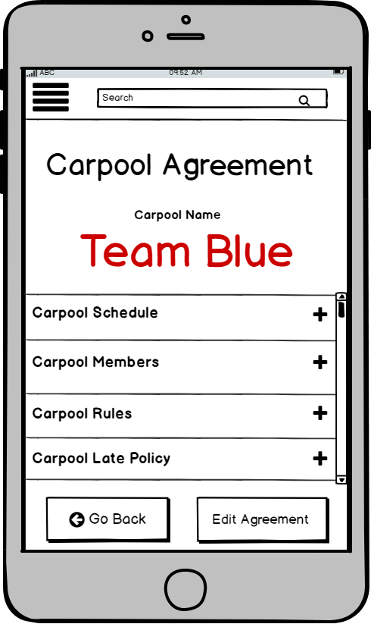

**Additional Comments:**

________________________________________________________________________________________________________________________________________________________________________________________________________________________________________________________________________________________________________________________________________________________________